You can choose any methods to setup your task.
Method1: Options you have to enter value when choose smspva phone service to register:
UserNameTable: the username you want to use when register.
Sex: enter number 1-4 represents male, female, not say, and other. 1-male, 2-female, 3-not say, 4-others
EmailTable: the recovery email address. We suggest enter your email address. Because if Gmail asks you verify this account in the future, then you can find your account back easily.
FirstAndLastNameTable: the first and last name you will use when register.
ProxyTable: please use http proxy or mobile proxy. The proxy format is: ip:port or ip:port:username:password
ApiKey: enter your smspva account apikey here. Register an account in smspva.com, then charge for your account, then you can find the apikey in your account profile.
IsUseMailSetting: this one means if you will go to edit the email account pop/imap settings after registered account successfully. Please enter value 0 or 1. 0-no, i do not want to edit the mail settings. 1-yes, i need to edit the mail settings.
PhoneService: enter 1. 1-use smspva phone service to solve the phone verification.
PhoneCountry: choose which country phone number you want to use from smspva. Eg: 0-Russian, 1-Latvia

Method2: Options you have to enter value when choose getsmscode phone service to register:
UserNameTable: the username you want to use when register.
Sex: enter number 1-4 represents male, female, not say, and other. 1-male, 2-female, 3-not say, 4-others
EmailTable: the recovery email address. We suggest enter your email address. Because if Gmail asks you verify this account in the future, then you can find your account back easily.
FirstAndLastNameTable: the first and last name you will use when register.
ProxyTable: please use http proxy or mobile proxy. The proxy format is: ip:port or ip:port:username:password
SMSUserName: enter your getsmscode account username. Register an account in getsmscode.com then charge for your account, then you can find your getsmscode username.
SMSToken: enter your getsmscode account token. Register an account in getsmscode.com then charge for your account, then you can find your getsmscode token.
IsUseMailSetting: this one means if you will go to edit the email account pop/imap settings after registered account successfully. Please enter value 0 or 1. 0-no, i do not want to edit the mail settings. 1-yes, i need to edit the mail settings.
PhoneService: enter 0. 0-use getsmscode phone service to solve the phone verification.
PhoneCountry: choose which country phone number you want to use from getsmscode. Eg: 0-Chinese, 1-Cambodia
How to create the task?
- Click this character “+” to create a task, then just name it:
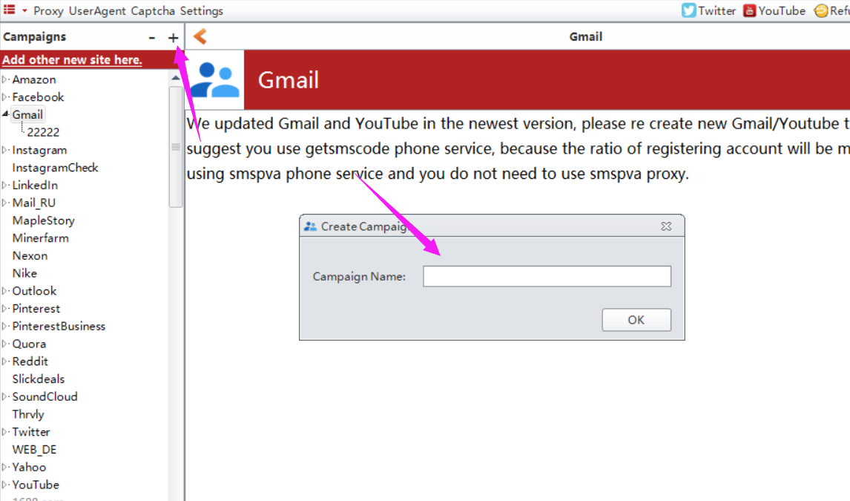

How to enter value for these options?
1. manually input value for them one by one.
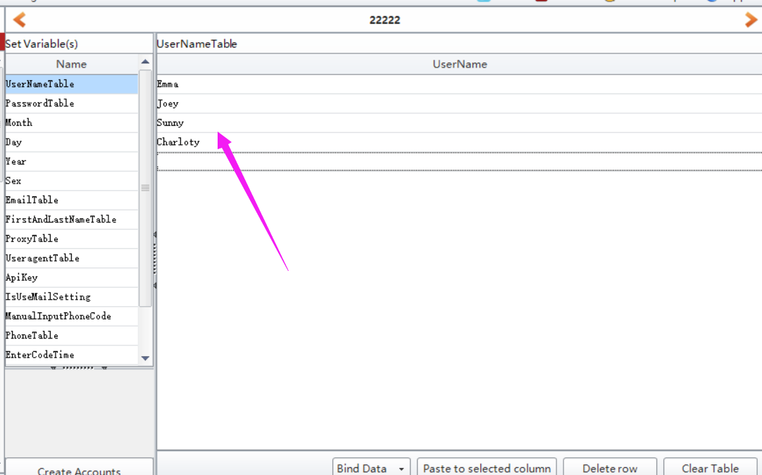
- click “BindData” to choose “Import from file” option to upload multiple data at a time.
Note: please check this column (the checked column color will be yellow) first which you need to multiple upload data.
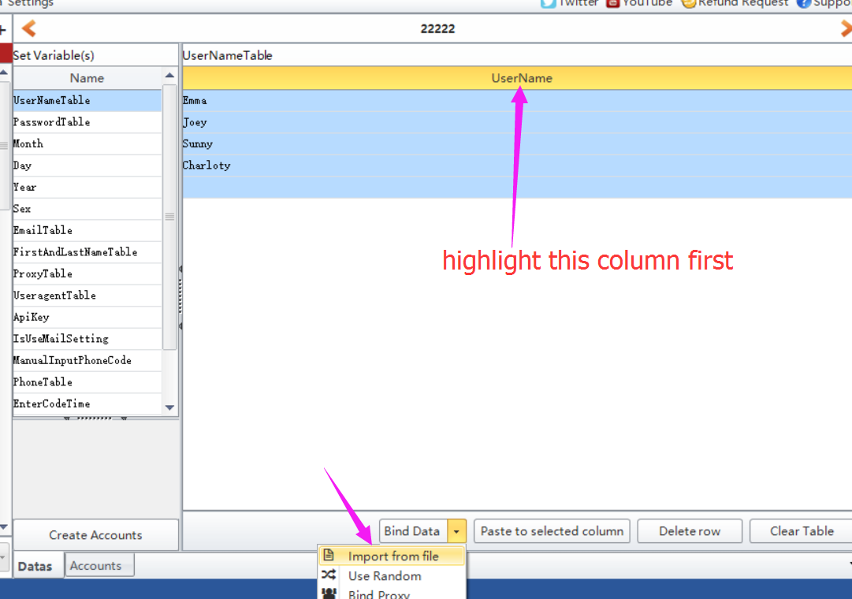
- click “BindData” to choose “Use Random” option to auto generate some data based on the condition you preset.
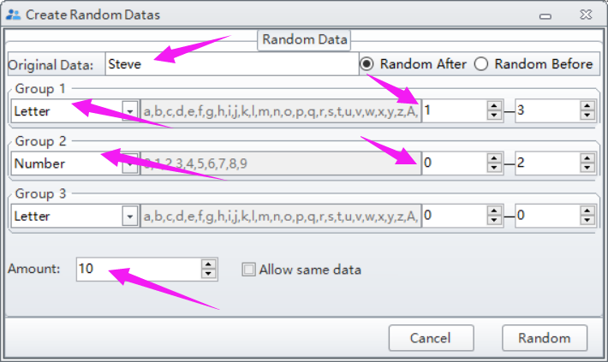
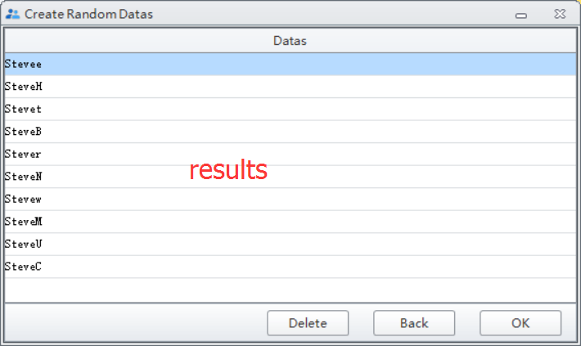

Note: please do not forget to click “Create Account” button to save the data you entered/modified.
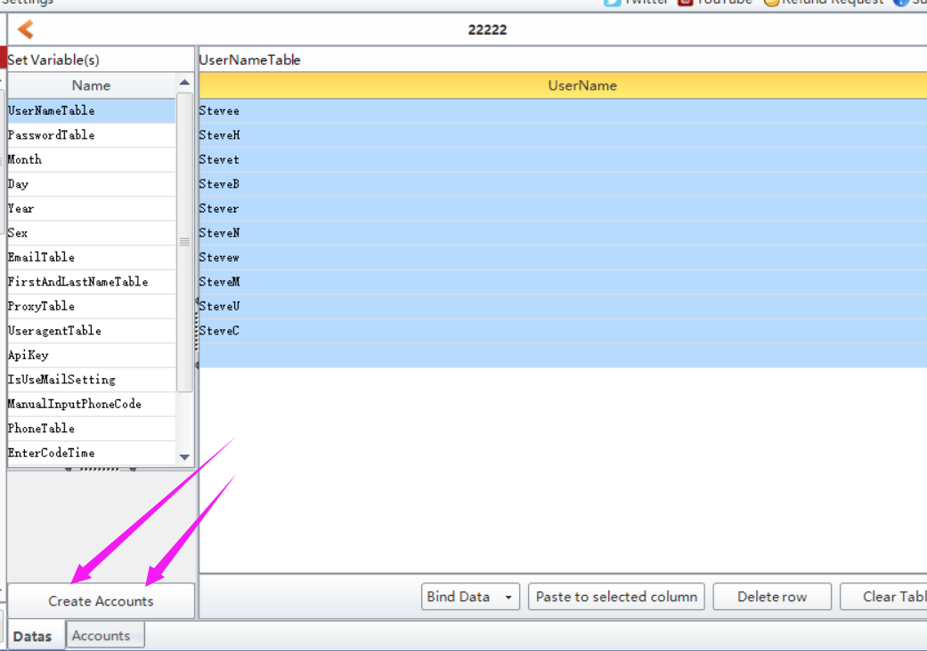

Where to find the data i entered?
Click Accounts button, then you can find all data you entered in this form:

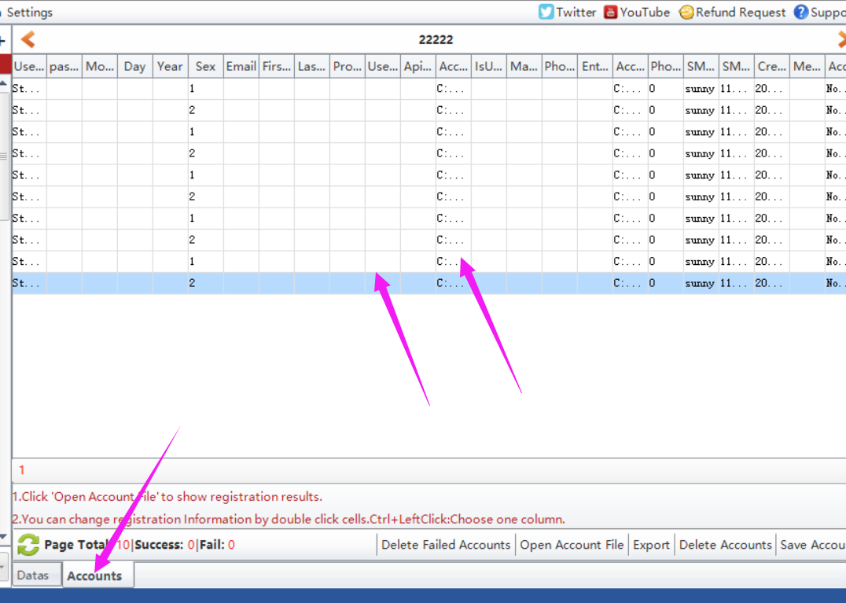

Where to start to run the task?
Click Start button to run.
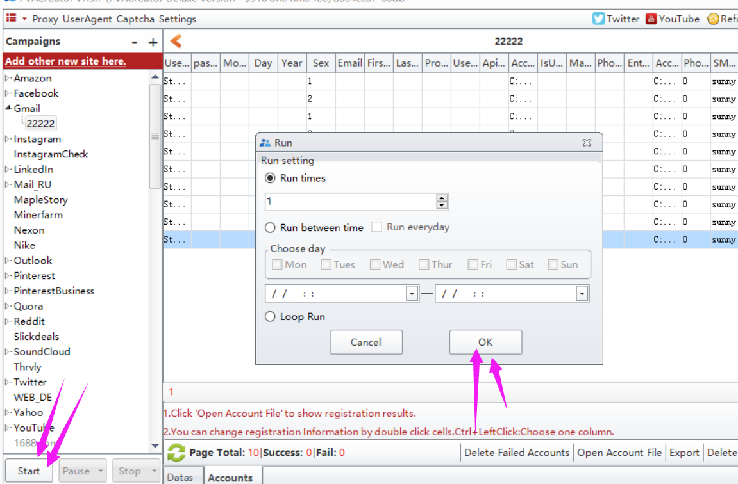

以下是运行前必填的参数。
TableUserName:
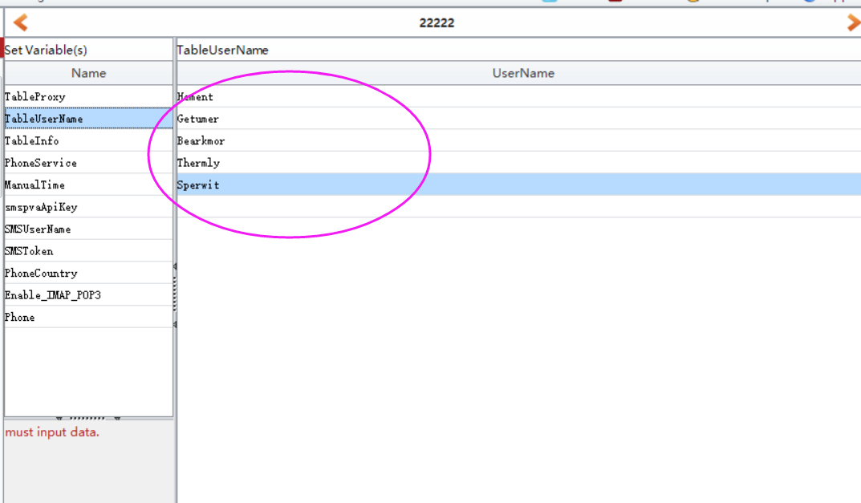
TableInfo: 除了recovery email 这一栏我们建议需要填写数据外，其他栏可以不填写。 填写recovery email后，如果以后Gmail 要求验证账户，你可以通过邮箱找回。
PhoneService: 输入1或者2 来选择你需要使用的手机服务。目前PVACreator支持2个手机服务，一个是getsmscode， 一个是smspva
smsApiKey: 如果PhoneService的值是1， 表示你选择的smspva手机服务，这个时候需要你访问smspva官网，注册账户，然后充值，然后将账户的apikey填写到这一栏。
SMSUserName/SMSToken：如果PhoneService的值是2， 表示你选择的getsmscode手机服务， 这个时候需要你访问getsmscode官网，注册账户，然后充值，然后将账户的username，token填写到软件中。
PhoneCountry: 根据选择的手机服务选择将要使用哪一个国家的号码注册。程序中按照手机服务将各个国家的号码列举出来了的。
其余的选项都可以不填写值。但是如果你有代理，最好的注册的时候使用不同的代理。
值填写完后，注意点击Account Create 按钮保存值。 以后修改了某一个值也要记住点击这个按钮保存修改
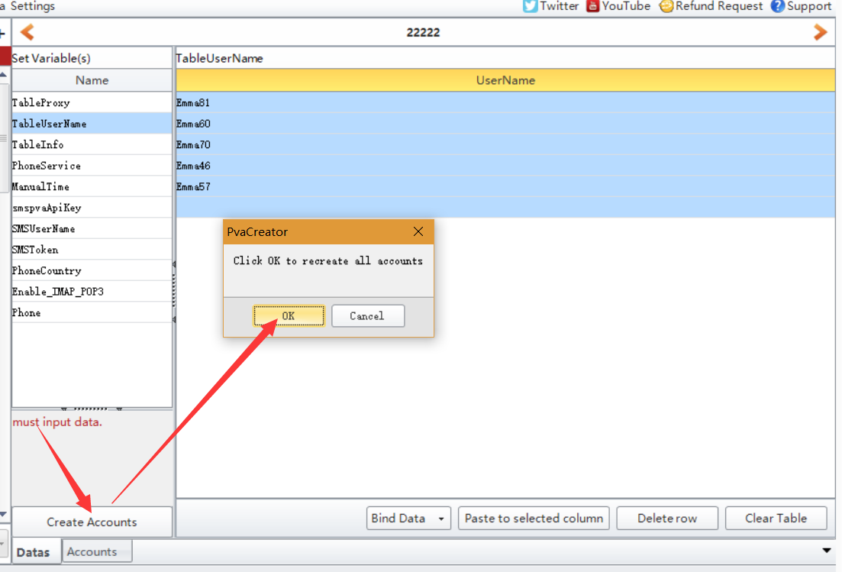
填写值的方法：
可以双击每一行手动的一个一个填写值。或者选中当前参数的名字（选中之后，该栏的颜色是黄色），然后点击Bind Data 按钮选择“Import from file”“Use random”按钮从你的本地文件导入数据或者使用程序随机生成数据。后面2个选项是批量导入代理和useragent。
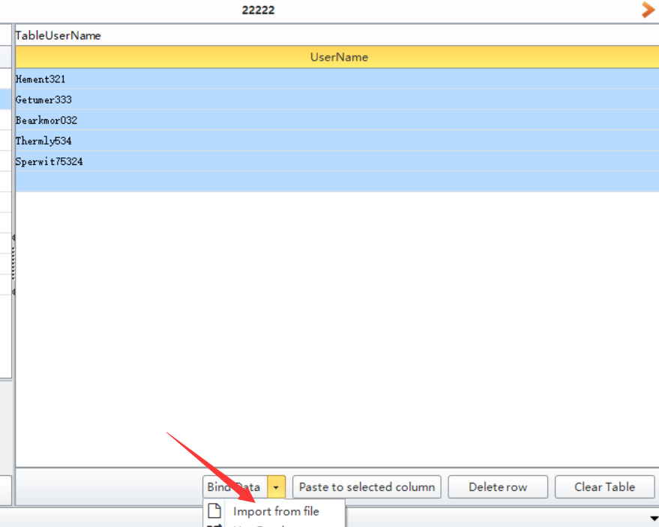
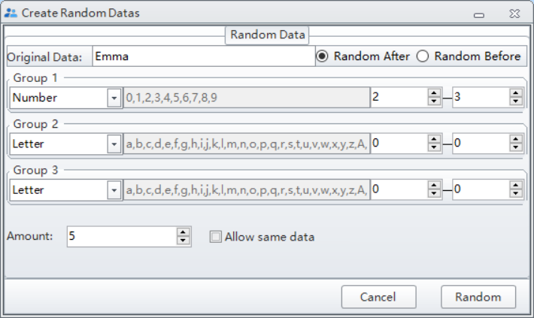
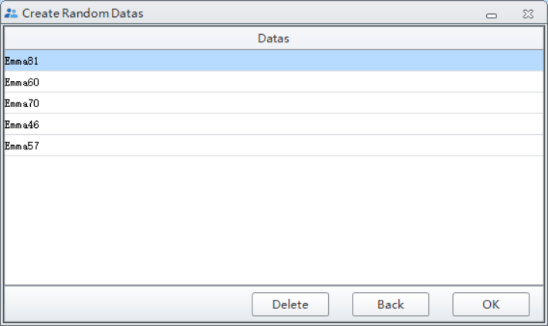

处理完以上步骤后，可以在Account界面查看设置的这些数据，然后点击Start按钮开始运行，程序运行的时候会有一个弹窗出现，你可以在弹窗中查看程序的详细运行过程。
在Account界面的底端，可以导出注册成功的账户（Open Account File）, 删除注册失败的账户（Delete Failed Account）,导出账户是筛选（Export）,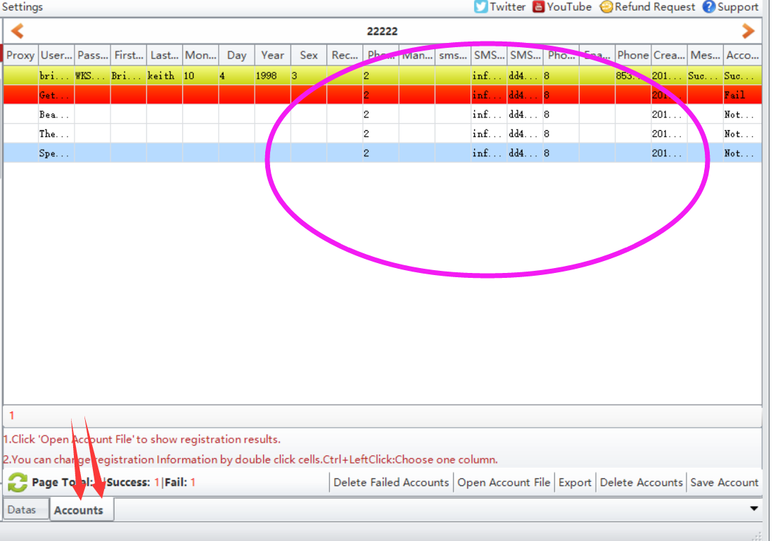
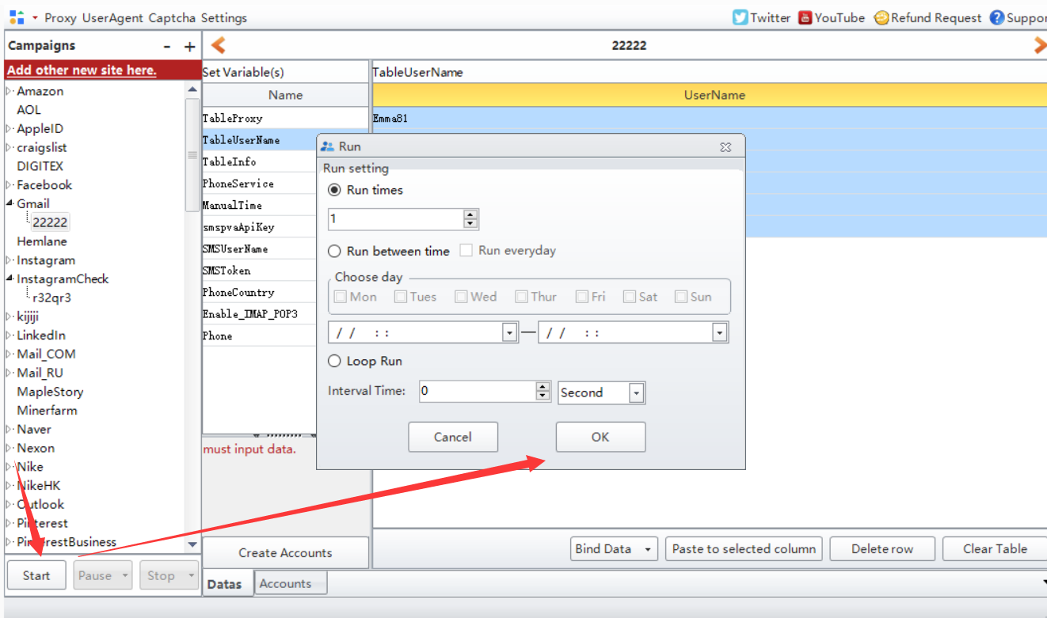

TableUserName:
TableInfo: all data can be empty except the recovery email. If Gmail asks for email verification in the future, then you can get your account back via your recovery email.
PhoneService: enter 1 or 2 to choose which phone service you will use. Here are 2 phone services you can choose. One is getsmscode, the other is smspva
smsApiKey: enter your smspva account apikey here. Register an account in smspva, then charge for your account, then you can find your account apikey in your profile field.
SMSUserName/SMSToken: enter your getsmscode account information here. Register an account in getsmscode, then charge for your account, then you can find your account username and token.
PhoneCountry: choose which phone service and which country phone number you will use to register account.
Please choose one of phone service to use. If you have proxy, you'd better enter your proxies to TableProxy to register. Please use HTTP proxy.

Use own phone number to register:
Here are the necessary variables needed to enter data before run when you use your own phone number to register:
TableUserName:
TableInfo: You'd better enter your recovery email address to register which can help you find your account back if Gmail asks for verification in the future.
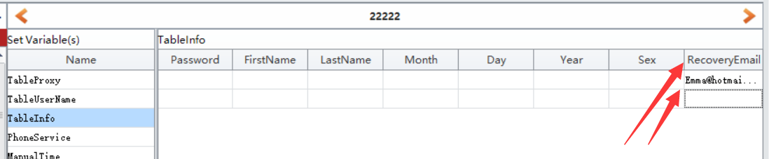
PhoneService: enter 0.
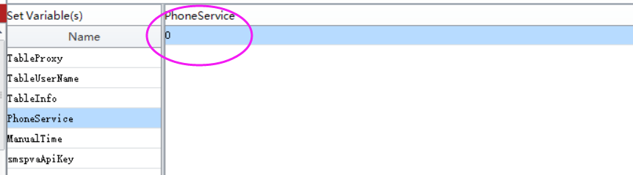
Manual Time: enter a time to pause the software for a while, then you do have enough time to enter your phone number and code to verify manually.
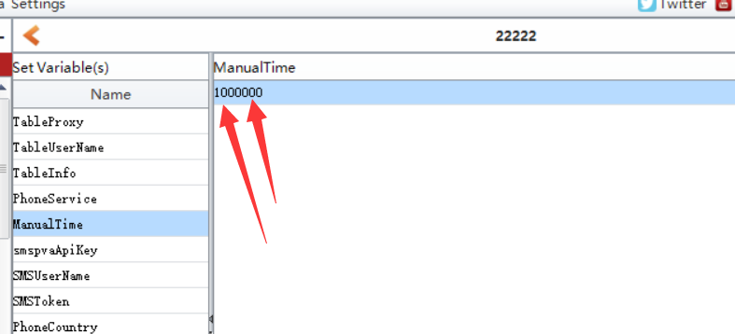
Phone: enter your phone number here. One number per row:
