Manual for Facebook

Click this character “+” to create a task, then just name it:
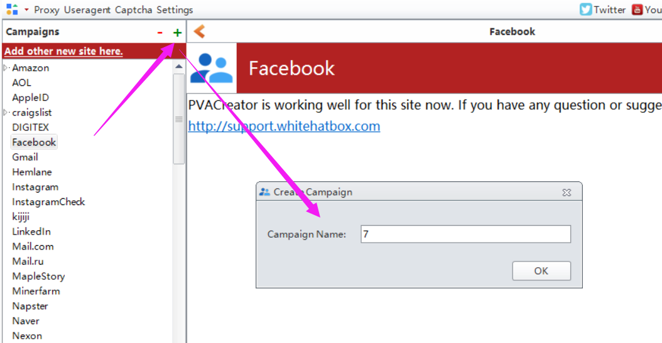

Following are the necessary variables needed to enter data before run：
- Email Information
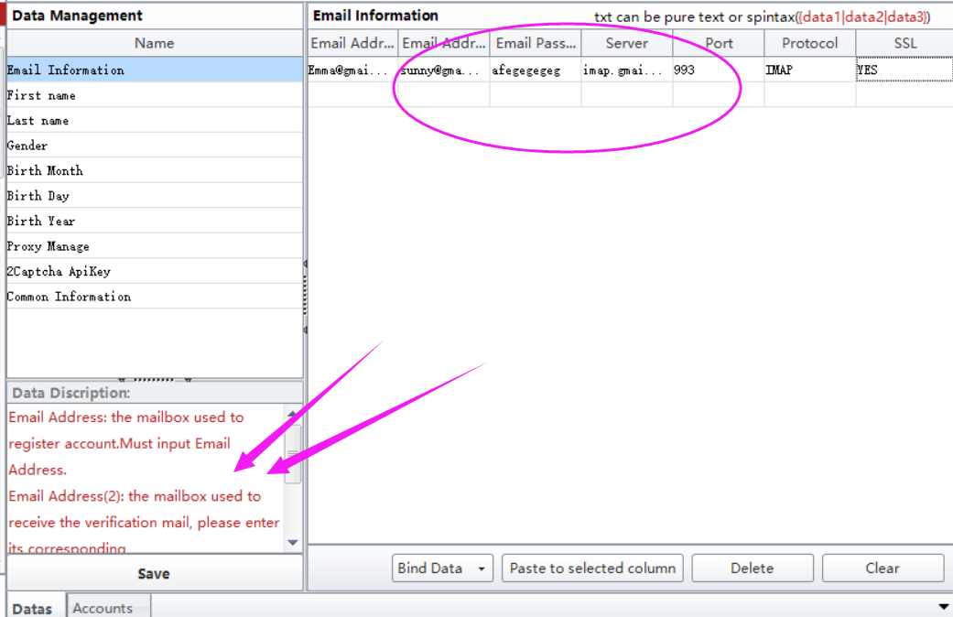
If you are using other domains to register account, and if you do not know where to find the server information, you can Google it, or follow this manual to check if you can find the related information. I will send it this file to you attached with this manual.
Here are two Email Address parameter in this form. One is used to register Facebook account, and the another one is used to receive and auto verify the verification mail if all of your mails from the 1st registered email address have been forwarded to this account.

2, 2captcha ApiKey
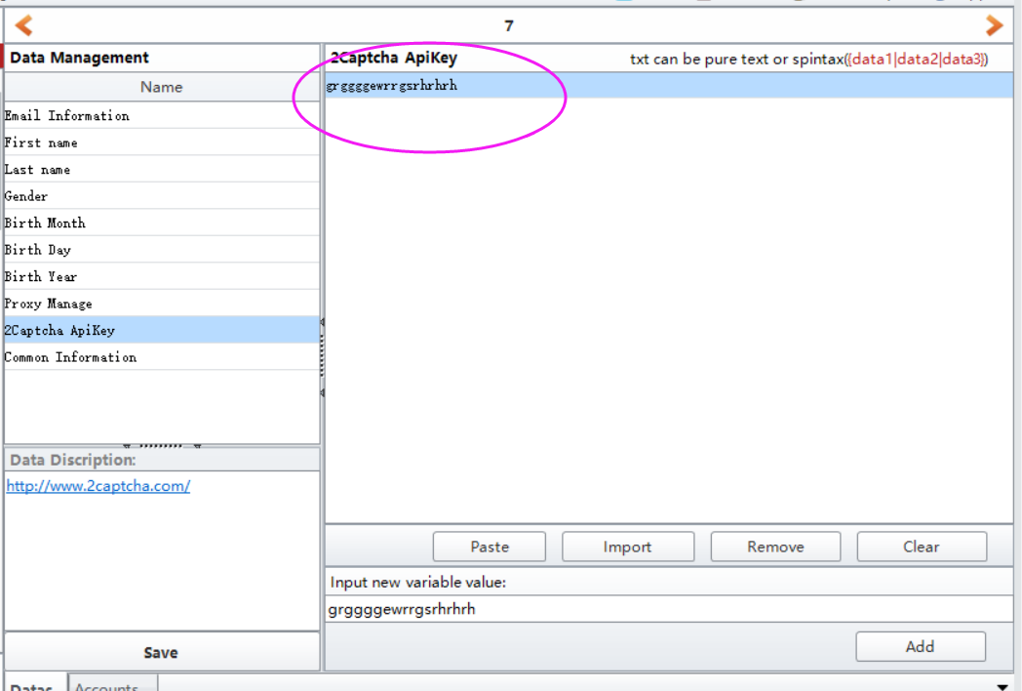
Visit 2captcha website, then register an account, then charge for your account, then enter your account apikey in this filed. If Twitter asks for captcha during register, then software will auto use this service to auto solve it.
https://2captcha.com/

3, Proxy Manage
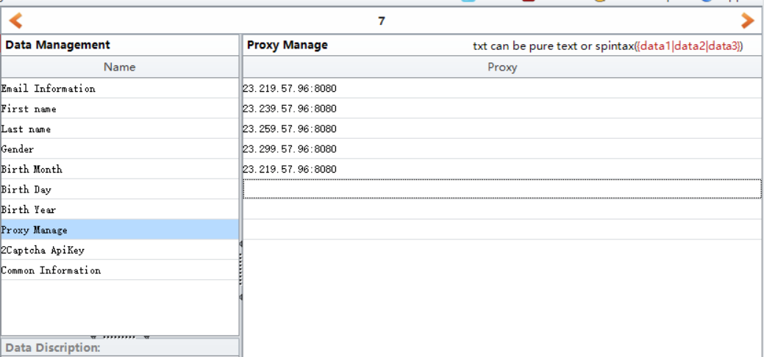
If you do have proxies and wish to create many accounts, then please enter your proxies in this filed. Please use HTTP proxy.
Proxy format can be: ip:port or ip:port:username:password
Eg: 23.219.57.96:8080 or 23.219.57.96:8080:proxy username:proxy password

4, Save
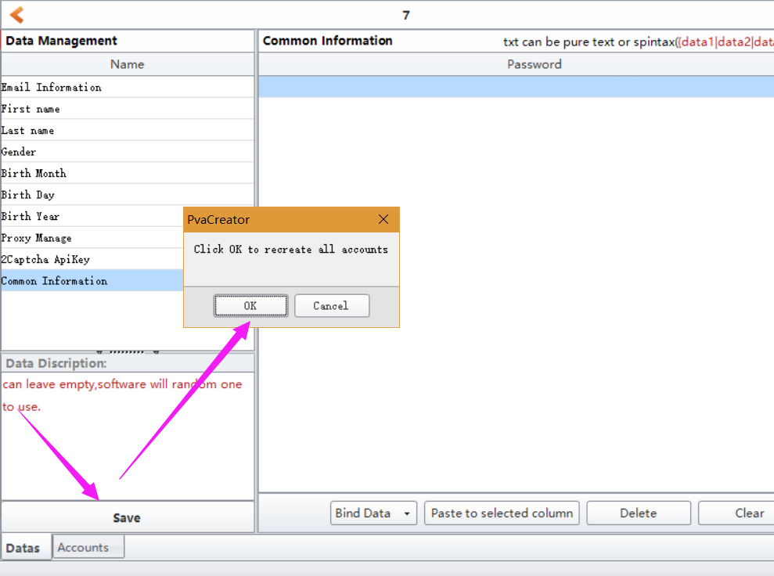
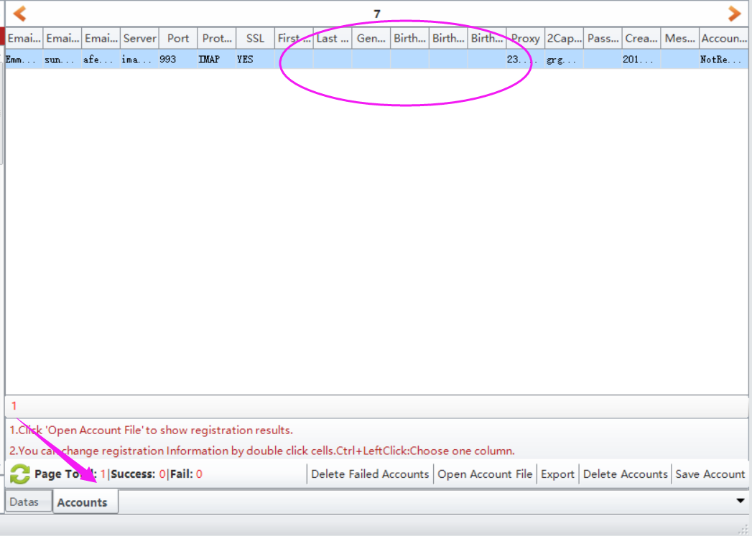

5, click Start button to start to run.
When it starts to run, here will be a debug window open, and you can view the whole running process.
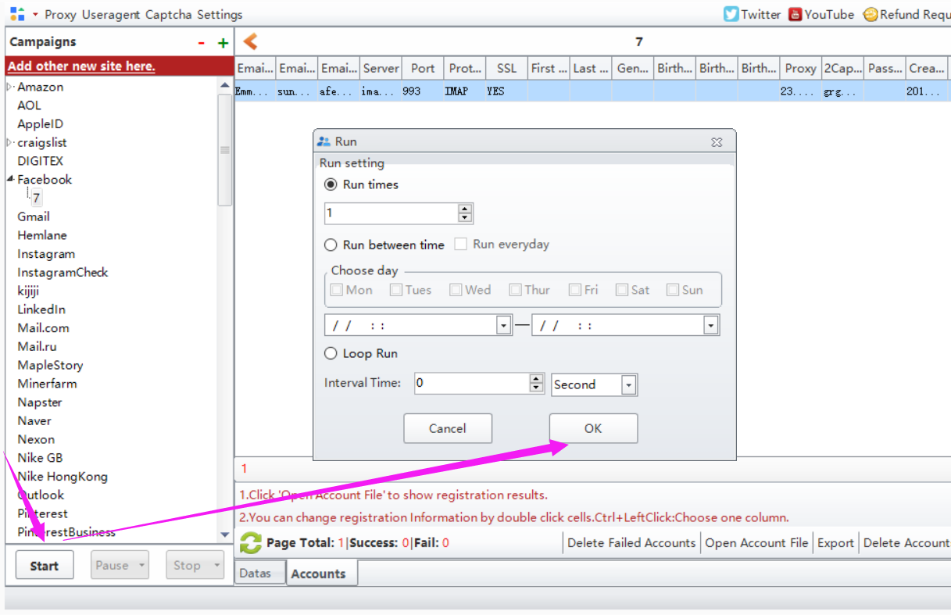

Options under “Bind Data”:
Import from file: import the data from your local prepared file at a time. Note: please choose the column first where you need to upload the data to.
UseRandom: custom some letters, numbers to auto generate data for these information. Such as full name, age, password. Note: please choose the column first where you need to custom and auto generate data.
Eg: if the first character is Funny, i will auto generate 1-4 number behind it. The first picture is the settings, the second one is the result it generates.
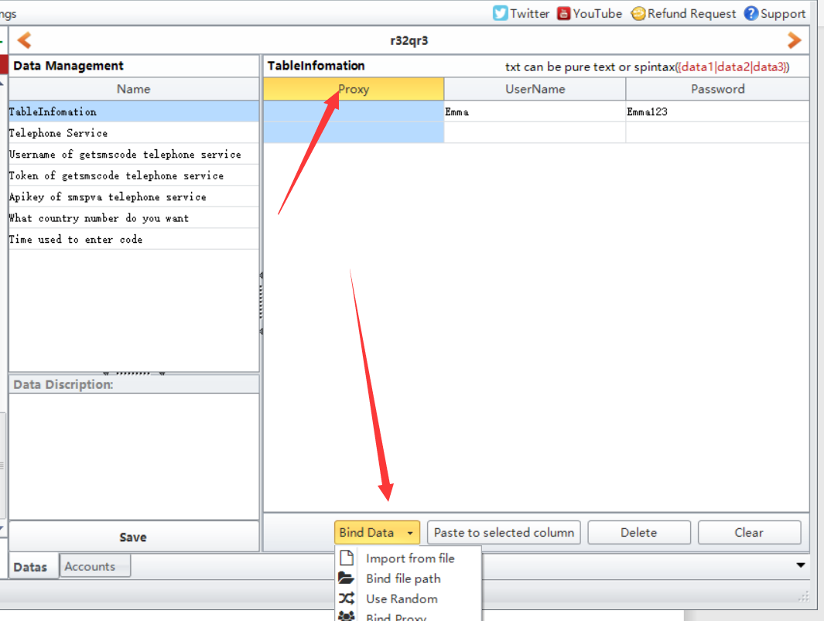
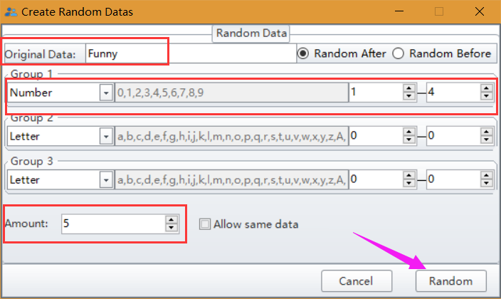
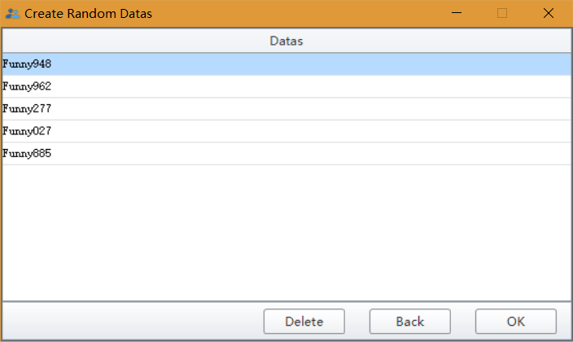
Bind Proxy/Useragent: bind proxy/useragents to these data at a time.

