Naver manaul
1.TableProxy: the software only support http proxy, it’s format is 127.153.219.149:8080 or 127.153.219.149:8080:username:password

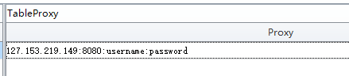
2.TableInfo: UserName cannot be empty, then other data can be empty, the system will random one.
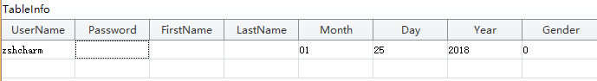
Follow this one to input Month and Gender if you want to fill in them by yourself:
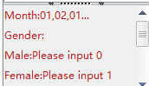
3.TableRecoveryEmail: only need to fill in Email.
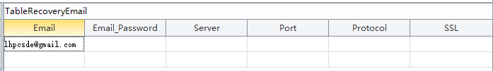
4.PhoneService:this is used to solve the phone verification.
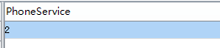
Follow this to choose one phone service you want to use:
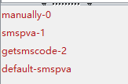
5.ManualTime:Leave it empty if you used phone service.
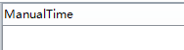
6.If you used smspva service, then only need to fill in smspvaApikey.
If you used getsmscode service, then only need to fill in SMSUserName and SMSToken.
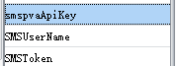
How to use the phone service?
Register an account at smspva.com or getsmscode.com, then charge for your account, then find your api in your account panel.
7.PhoneCountry:
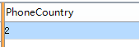
Follow this to choose the phone country to verify it.
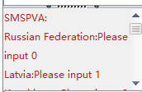

How to use getsmscode service:
1.1.Charge your getsmscode account first (if you don't have account, sign up first), then go to User Center, click Project List, , so just Favorite Naver project.

After done the first step, click User Center, then please notice your username and token, for token , click Show me token button, then you will find your token.
Then please copy your username and token to the program :
username -> SMSUsername variable,
token ->SMSToken variable.
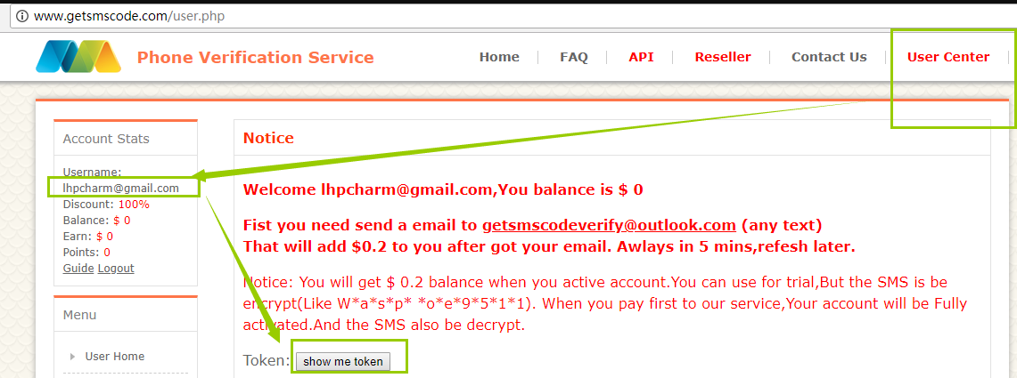

After you finished all these variables, then click Create Accounts button first, then click Start to register accounts.

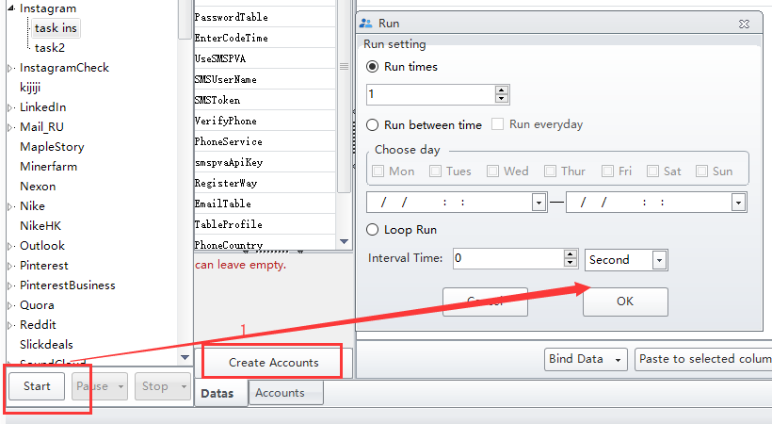
You can check the details in Account module:
